**29-09-2022 Assignment - 1 Name : Harshini K**

**Dataset used :** 50-startups-dataset

1. Network visualization to show R&D spent by the administration

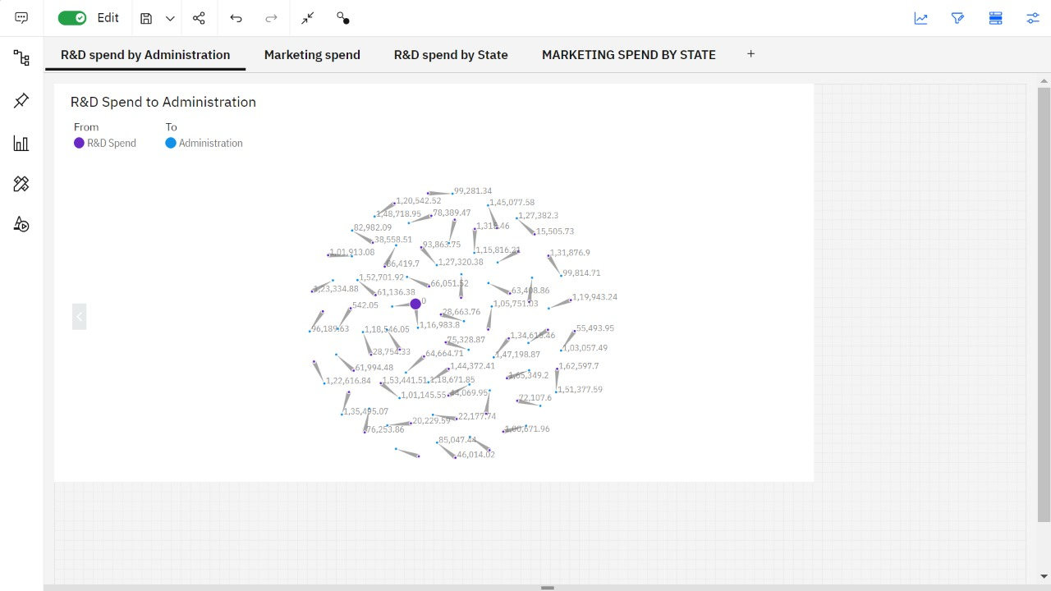

1. Spiral representation to show amount spent on marketing

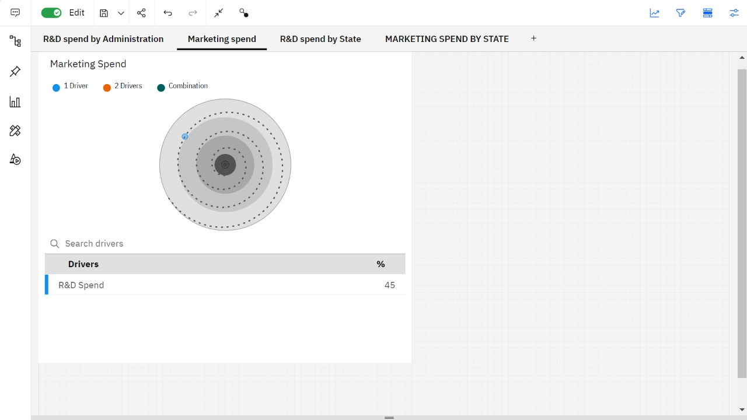

1. Line graph to show the amount spent by R&D on each state

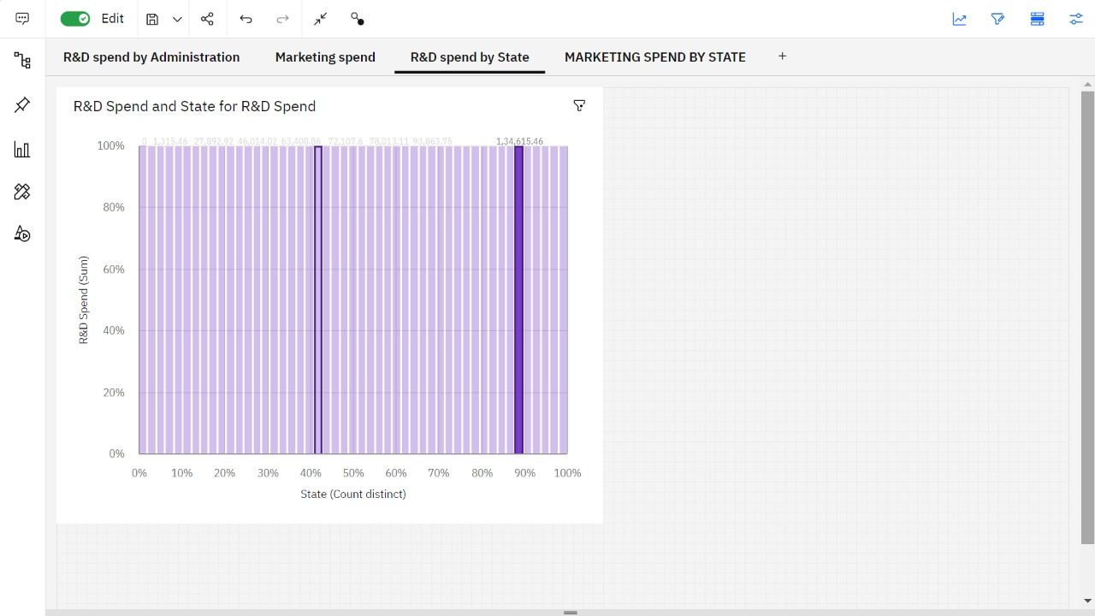

1. Map visualization to show the amount spent by every state

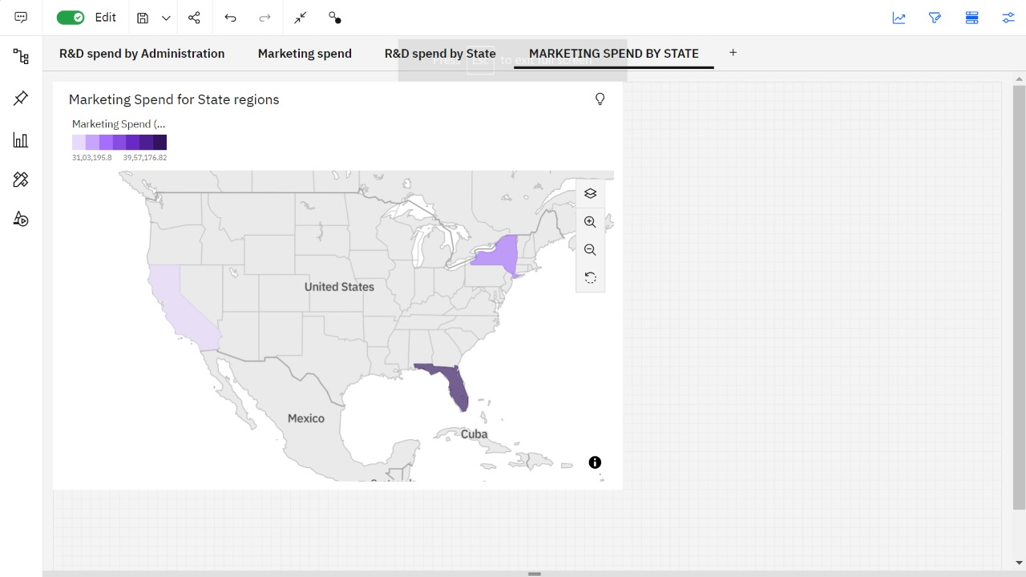

**Dashboard :** https://ap2.ca.analytics.ibm.com/bi/?perspective=dashboard&pathRef=.my_folders%2F19i319%2BHarshini%2BK%2BAssg-1&action=view&mode=dashboard